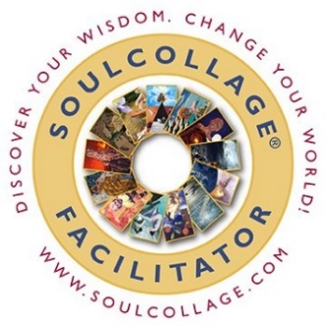

SOULCOLLAGE® FACILITATOR TRAINING
- Starting Saturday 21st September (09h00 – 17h00)
- Sunday 22nd September (09h00 – 17h00)
- Monday 23rd September (09h00 - 17h00)
- Ending Tuesday 24th September (09h00 – 13h00)
- Venue: Century Square, Unit G5, Heron Crescent, Century City, Cape Town

Course rates for this training will be R 15 000 per person.

Trained SoulCollage® Facilitators wishing to refresh their skills qualify for a discounted fee of R 10 500.00 pp
Spaces are limited, please let me know by latest 15th August 2024 so I can prepare for the training.

Are you interested in becoming a SoulCollage® Facilitator?

Perhaps you have personally experienced the power of the SoulCollage® process to uncover and work with emotional or creative blocks using images, intuition and imagination, and would like to share the process with others and at the same time deepen your own SoulCollage® practice and connect with others who are sharing the process in the world.

You don't need any degrees or qualifications to take the Training, just a desire to share with others a process that will help them uncover their inner wisdom. Facilitators of this process come from many fields including therapists, coaches, artists and labyrinth facilitators.

Making SoulCollage® cards is a great way to integrate and deepen many modalities and is used in conjunction with the labyrinth, yoga, writing, the enneagram, as well as in hospice, addiction centres, spiritual centres and just as a way for people to gather together in a meaningful way.

By participating in this Training you will learn what is needed to share the SoulCollage® process with others. You will learn how to prepare for a workshop, create safe space for participants, do SoulCollage® readings, as well as how to promote your workshops. You will find out how to access the rich archive of information available on World of SoulCollage® to Facilitators and how to use the SoulCollage® website to share your workshops. You will network with like-minded people and become part of a world-wide community of Facilitators.
SoulCollage® was originally designed and evolved as an adult activity. Unless you are a licensed clinician or teacher working with children in schools or are under the direct supervision of teachers working within schools, SoulCollage® Facilitators are advised not to work with collage and emotional expression with children who are not their own children.
Once you've completed the Training you will receive a certificate entitling you to use the SoulCollage® trademark and logo in the work you do according to the Principles of SoulCollage®.

Please note that the Training is fast-paced and we cover a lot of territory in a relatively short period of time. It is not intended to be a retreat. Please come well rested and prepared to learn. This Training has been condensed to make it affordable, so every minute in sessions is essential.
The Training Schedule comprises 24 hours of instruction and includes some evening sessions. You must be on time and attend all sessions to receive your Certificate of Completion.
Before signing up for the Training, please visit the Free Facilitator Training Prep Course on World of SoulCollage® (cntrl + click for link) which will lead you through all the prerequisites and preparation you need to do for the Training.
For more information about SoulCollage® visit www.soulcollage.com
The book - Evolving: An Intuitive Collage Process for Self-Discovery and Community, by Seena B.Frost is essential reading before the training. The book is available to collect from my office, the cost is R900 should you not order one by yourself.
Let’s build and expand a community of SoulCollaging in SA!

Marita
For any questions or uncertainties, you can contact me on 083 360 0654

